**Project Report**

**Zhengyu Wang**

1. **Introduction**

This project wants us to be familiar with how various projections affect the visualization and interpretation of spatial data, paying particular attention to how changes in area and linear measures at various geographic locations such as forests and floodplains are affected. One portion of the project is to analyze Dutch provinces. Examining Dutch province borders, forests, and other natural areas.

Another portion of this project is to analyze Kenyan floodplain limits and southern Madagascar tortoise when using different projection coordinate systems. We will use the provided datasets to project two distinct PCS in order to determine which places are most impacted by distortions as a result of our projection choice.

The goal of this project is to compare the effects of data projection on distance and areal measurements.

1. **Study areas**
   1. **Netherland**

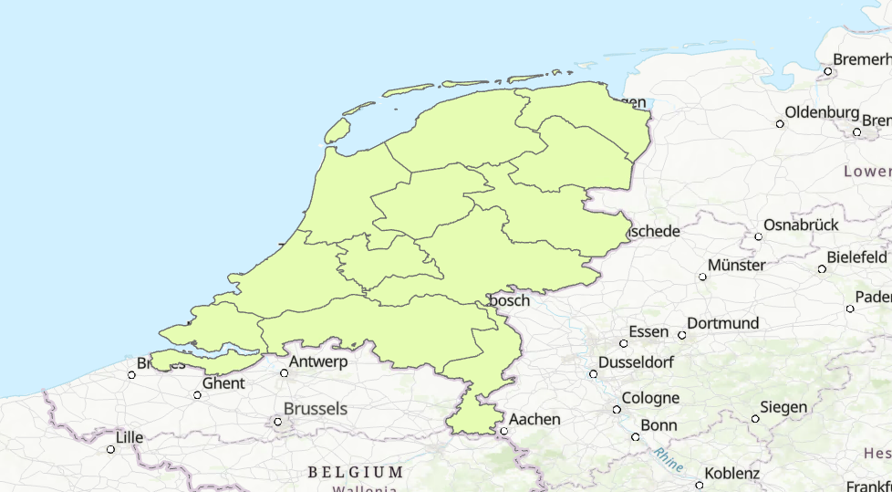

The shapefile of provincial Netherland gives us a view of the boundaries of provinces. The Netherlands is a country located in northwestern Europe with overseas territories in the Caribbean. It is the largest of four constituent countries of the Kingdom of the Netherlands. The Netherlands consists of twelve provinces; it borders Germany to the east, and Belgium to the south, with a North Sea coastline to the north and west. It shares maritime borders with the United Kingdom, Germany and Belgium in the North Sea. The country's official language is Dutch, with West Frisian as a secondary official language in the province of Friesland. Dutch, English and Papiamento are official in the Caribbean territories (Wikipedia Contributors).

* 1. **Kenya**

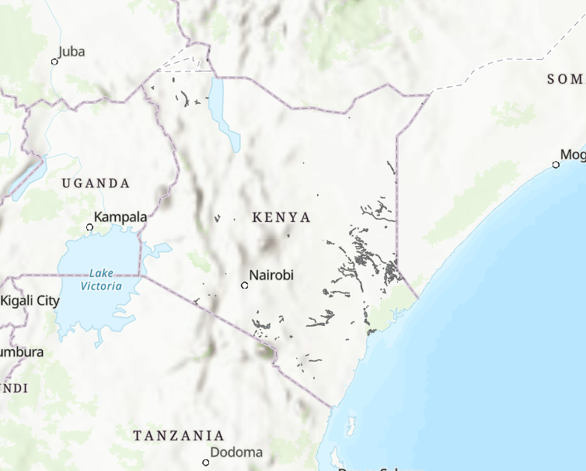

Kenya is the 47th-largest nation in the world (after Madagascar). It is located between longitudes 34° and 42°E and latitudes 5°N and 5°S. The low plains climb to the central highlands from the coast along the Indian Ocean. The Great Rift Valley cuts across the mountains, while to the east is a rich plateau.

One of Africa's most productive agricultural regions is the Kenyan Highlands. The highlands are home to Mount Kenya, the second-highest mountain in the world and the highest point in Kenya, as well as glaciers. You can view Mount Kilimanjaro from Kenya south of the Tanzanian border (5,895 m or 19,341 ft).

* 1. **Madagascar**

Madagascar is the second-largest island nation and the fourth-largest island in the world, with a total land area of 592,800 square kilometers. The majority of the nation is located between longitudes 43°E and 51°E and latitudes 12°S and 26°S. The state of Comoros and the French territories of Mayotte to the north-west are neighboring islands, as are the French territories of Réunion and Mauritius to the east. Mozambique, which is to the west, is the closest country on the continent. (Wikipedia Contributors).

1. **Data**
   1. **Shapefile of the provincial boundaries of the Netherlands (Netherlands_Provinces).**

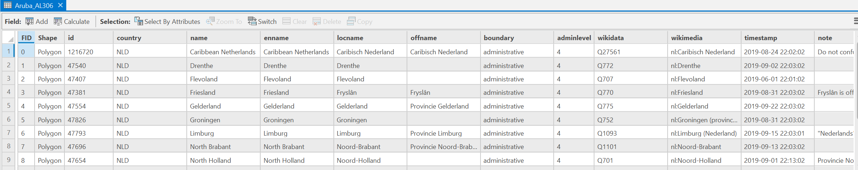

This dataset has multiple features. It includes names of provinces and has timestamps and paths and rpaths. Its geographic coordinate system is WGS 1984.

* 1. **Shapefiles of Kenyan flood plains and forests (ke_floodplains and ke_forests)**

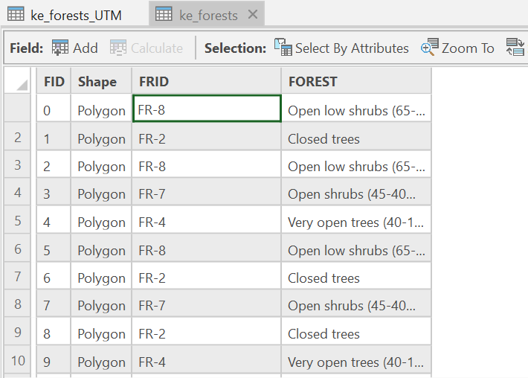

The dataset of forest has forestID, the shape of the area, and the detail of forest(open or closed trees)

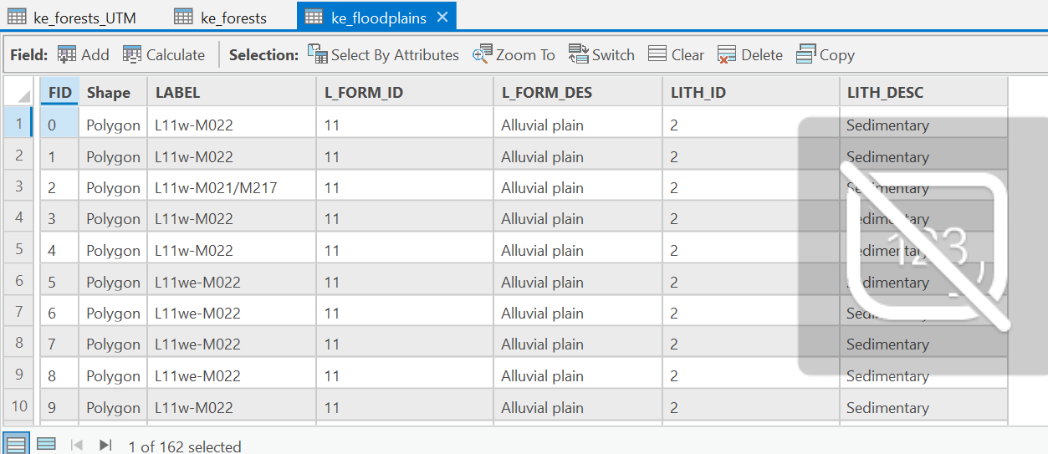

Compared to the attribute table of forest, the features of floodplains are more than the features of forest. It has the label of floodplains and other features which are all the same. The projected coordinate system is WGS 1984 UTM Zone 37S

* 1. **Spreadsheet of tortoise point data (Tranovaho_Madagascar_2014)**

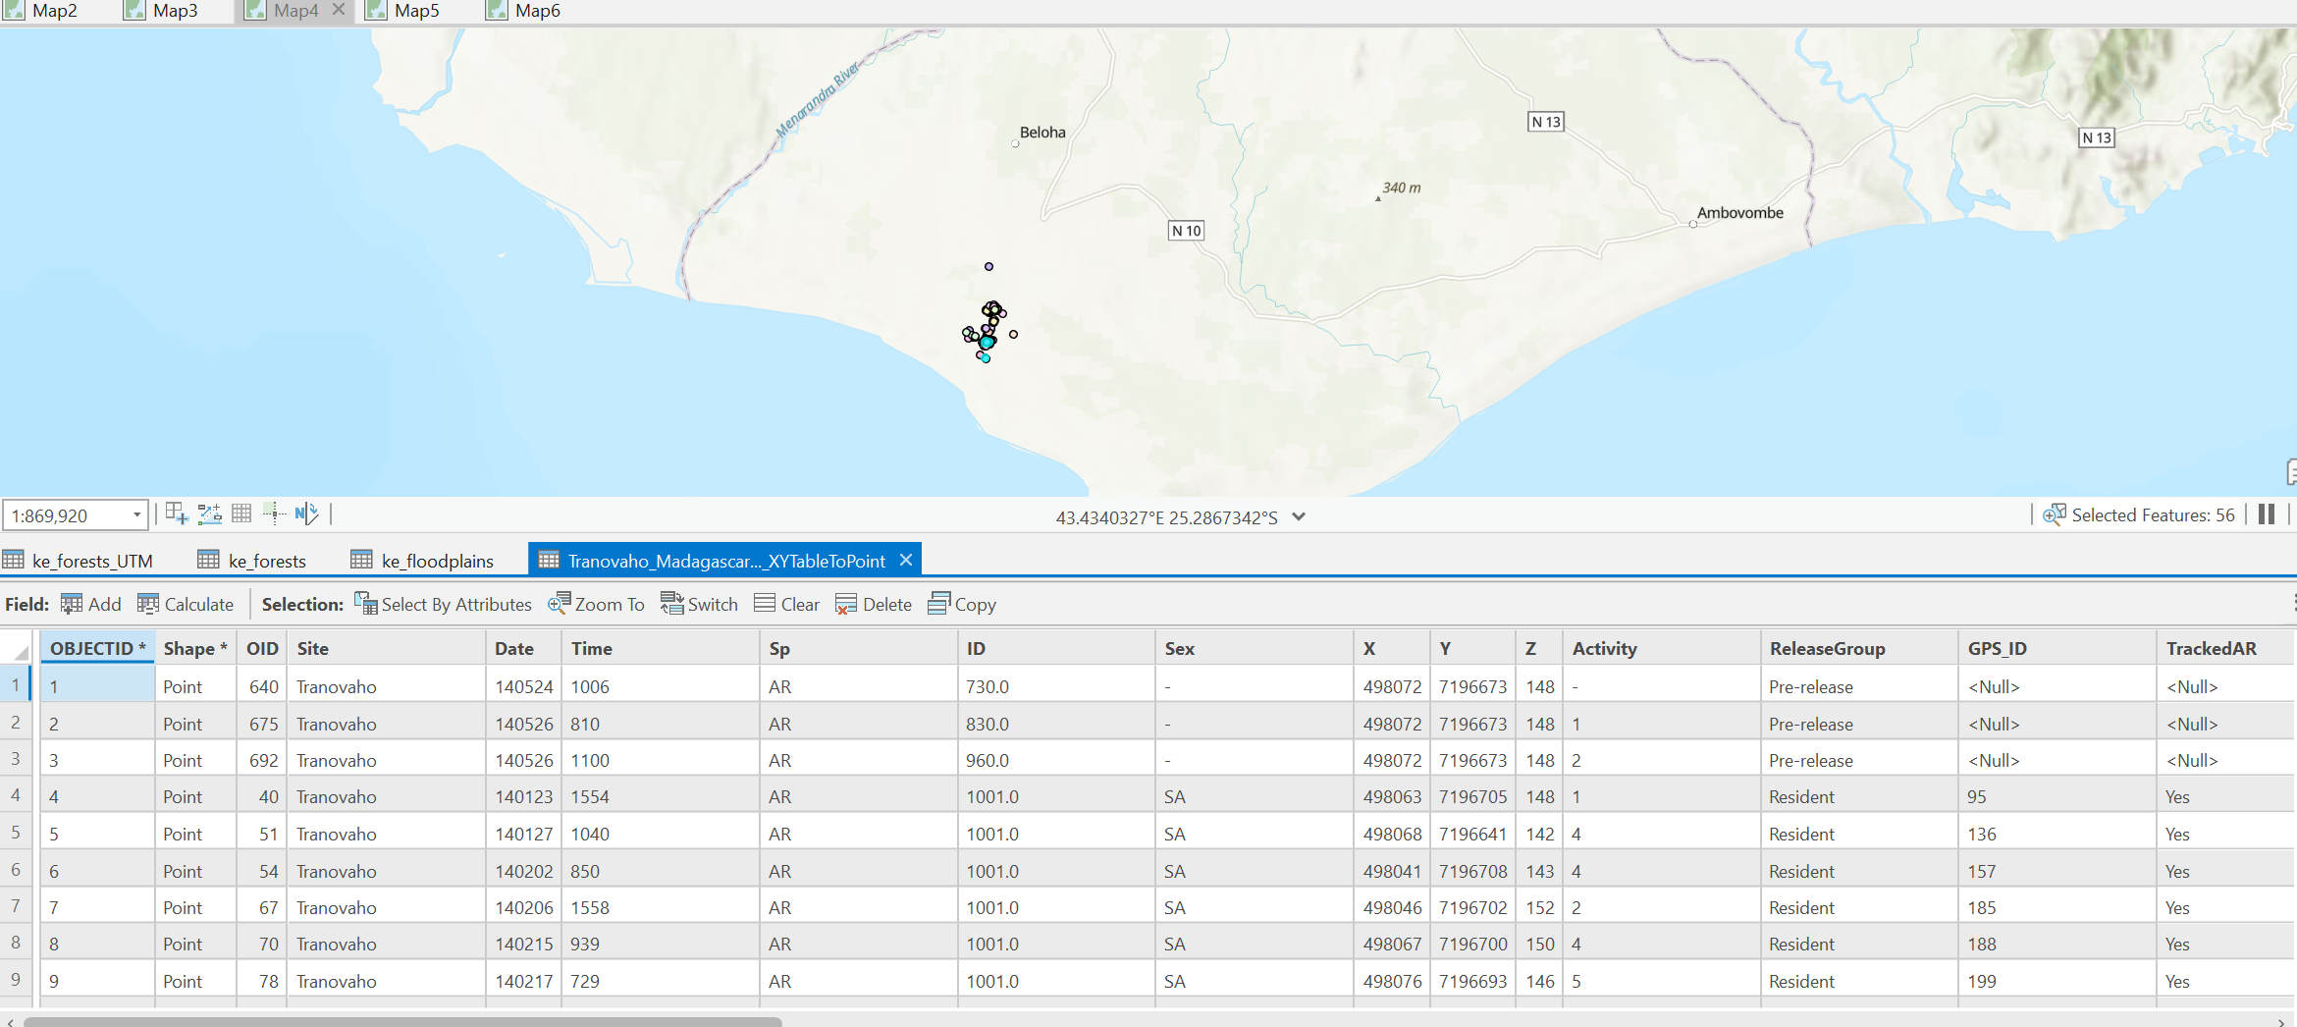

This dataset has many variables(when XYconverted to table, more variables added) including site, data, timestamp and ID. The projected coordinate system is WGS 1984.

1. **Methods**

I followed the steps illustrated in the instruction paper. Firstly, I added dataset into ArcGIS pro using “add data” function. And then using the tool “X Y to table“”, established a coordinate system for the dataset. Then I use the tool in geoprocessing called “project”. For each projected coordinate system I chose, I initially identify the location of the each study area. For instance, when I was studying Kenya, I googled the best UTM zone for Kenya because I want to find one optical zone that covers the whole Kenya(considering its longitude and latitude). Applying the optical zone, Kenya is now displayed in the center of the map.

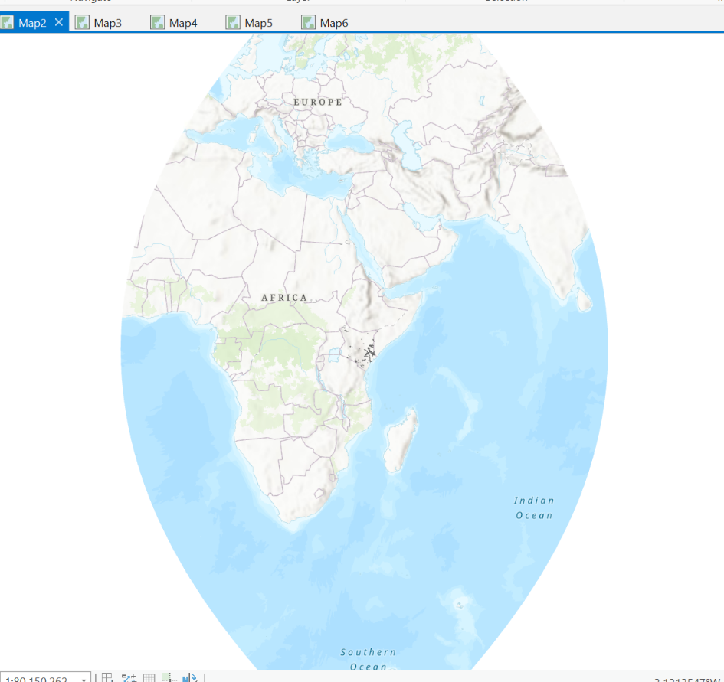

1. **Results**

This is process I chose the North Holland (except Aruba).

Firstly there are various attributes on the attributed table and most of them are related to province names and other administrative information. And then I projected the table into the UTM. And there are two new variables called Shape_Length and Shape_Area. And following the same steps, I project it into a new PCS web mercator. There are difference of the two new variables between UTM and Web Mercator.

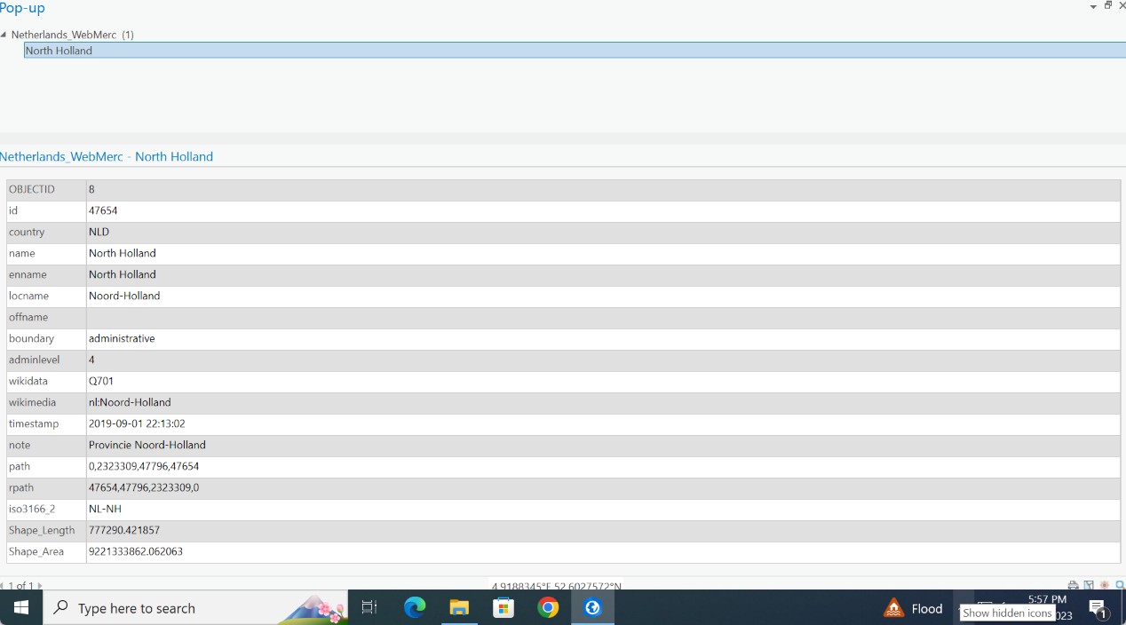

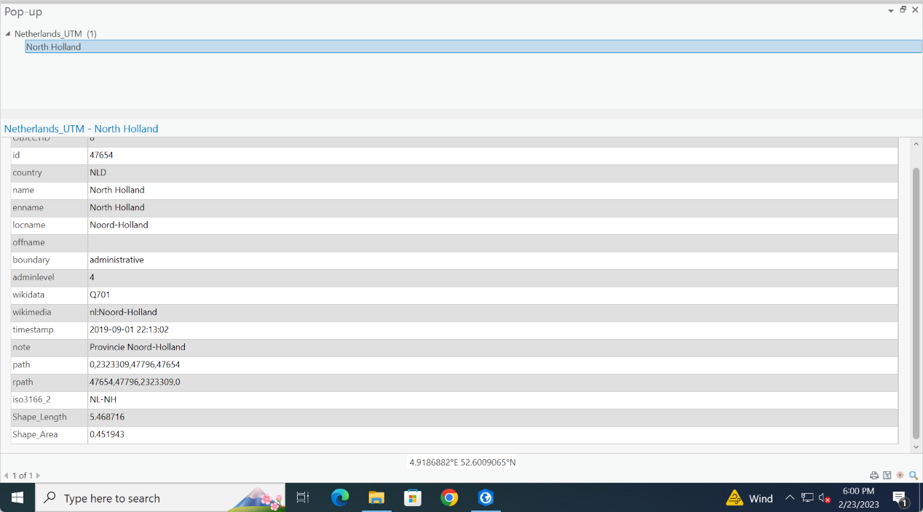

According to the map, there are also differences between the two projected maps. 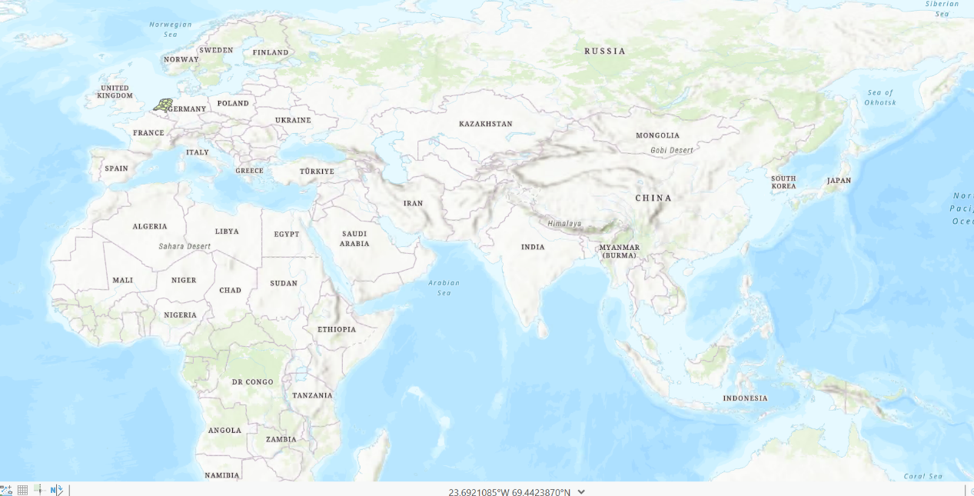

The UTM looks more like a sphere, but Web Mercator looks more flat.

Graphs below are the results of projecting the forest and floodplain of Kenya into new

Coordinate systems. I also used the “projcet” tool.

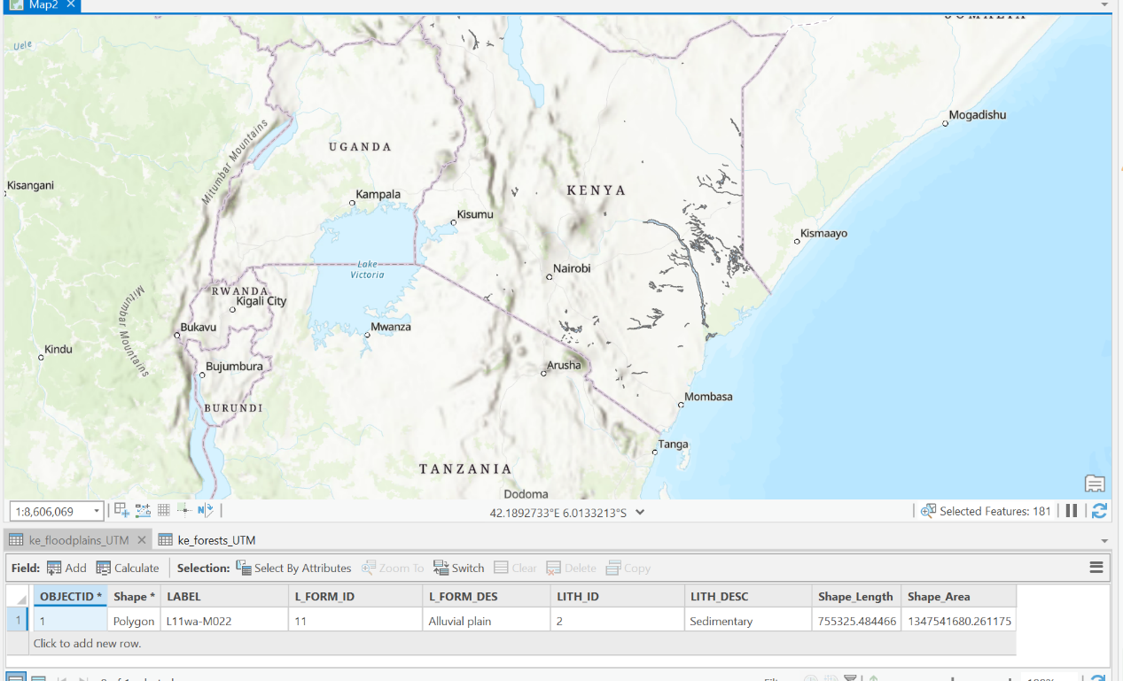

This is the floodplains in UTM and its attribute table.

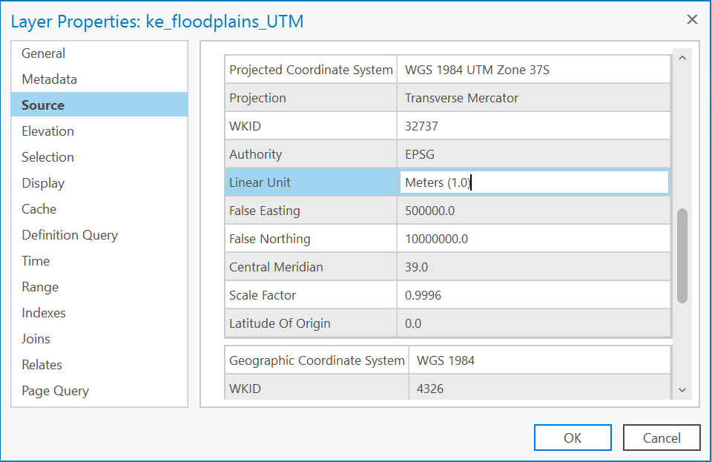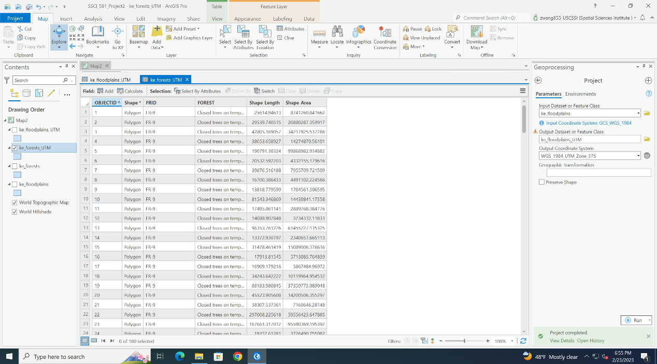

This is the floodplains in Web Mercator and its attribute table.

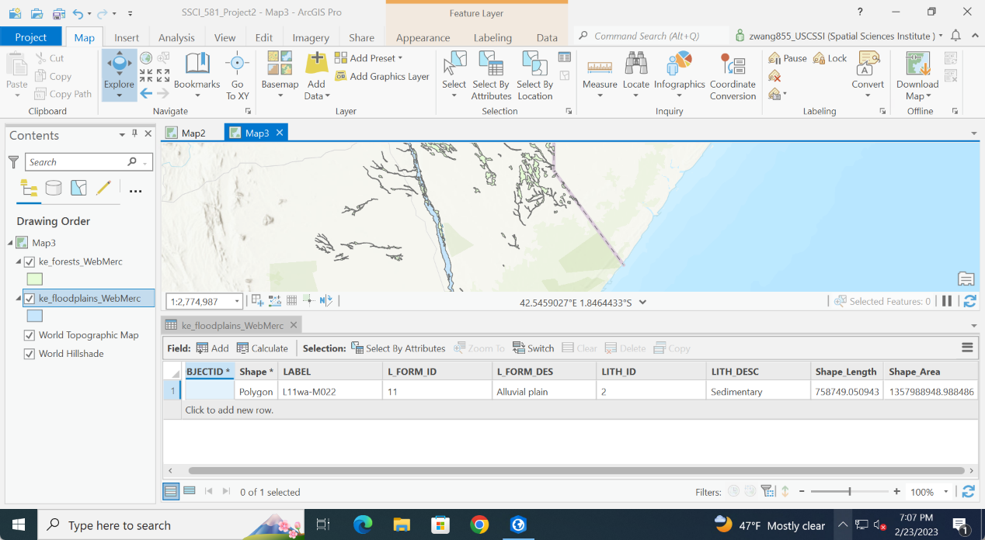

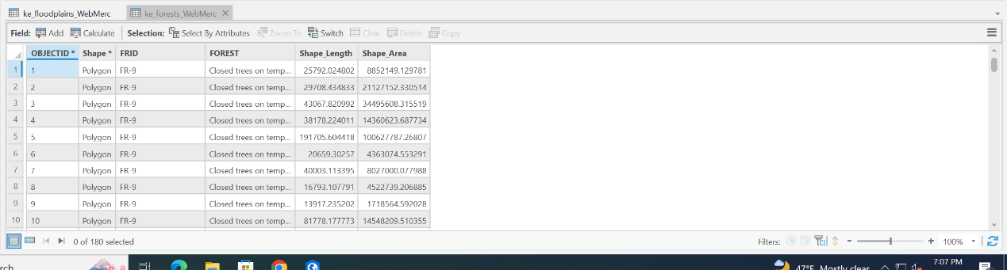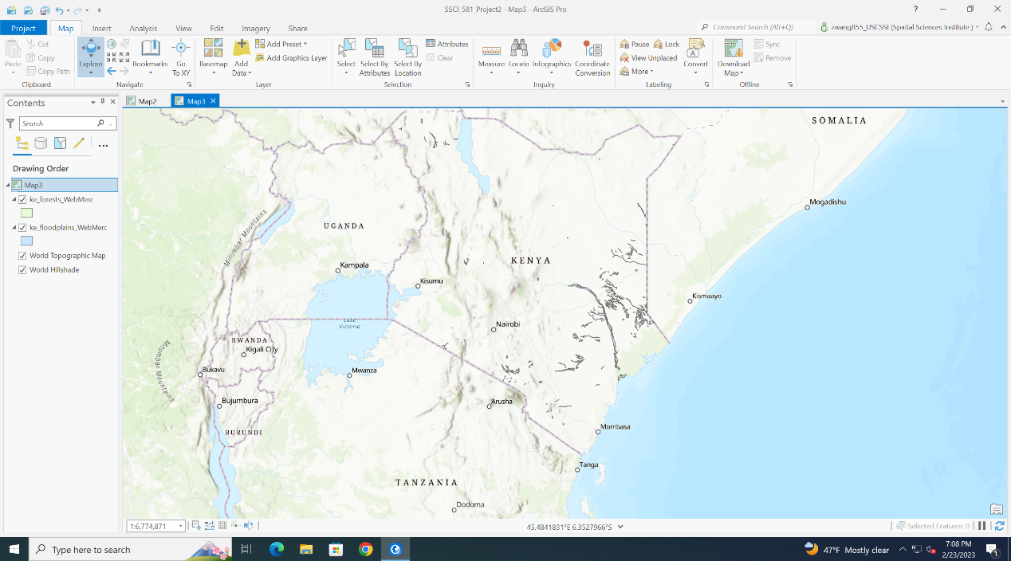

Distortion of distance because the distance is different

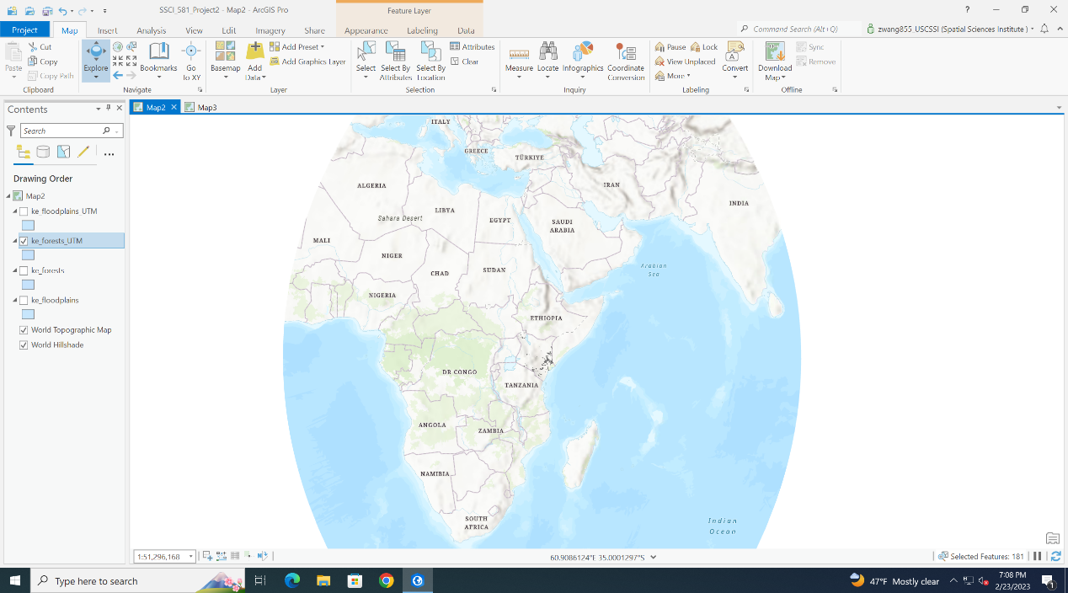

Distortion of size because the Shape_Area changes

UTM zone looks more vivid than Web Mercator because it’s more like a sphere.

And here are three points I chose in Madagascar. I chose the tortoises whose IDs are 1001,1002 and 1005. Firstly, they are displayed in UTM

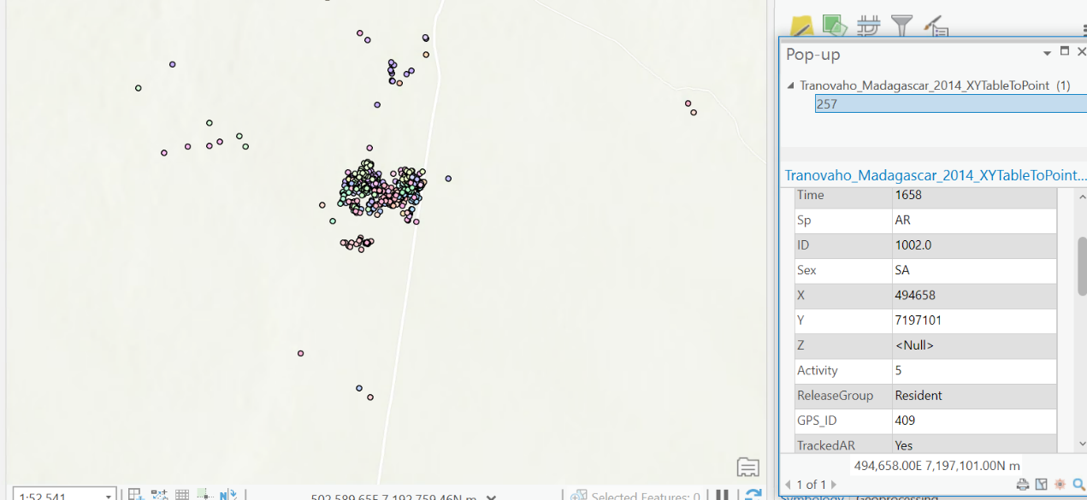

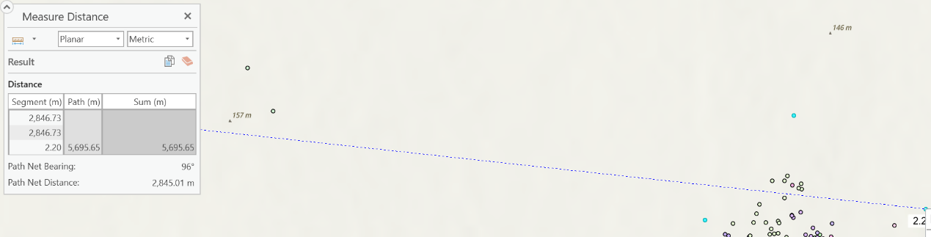

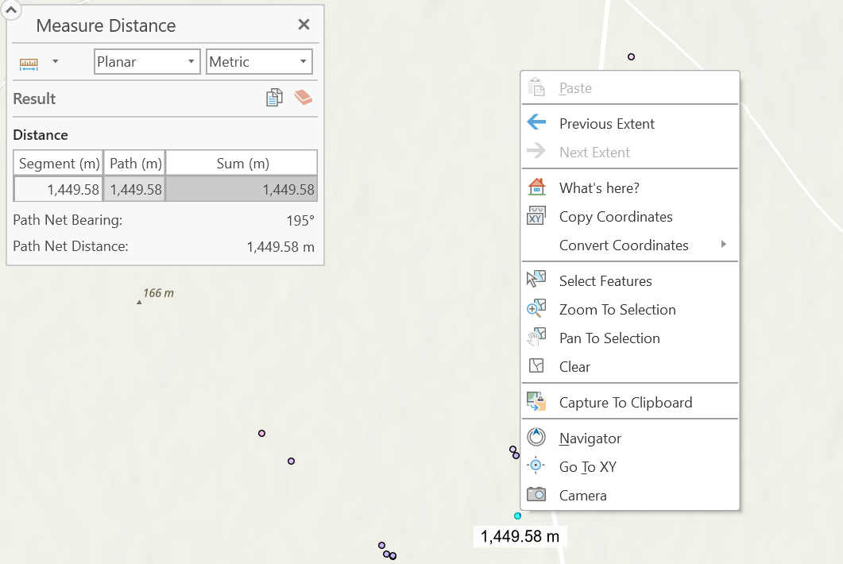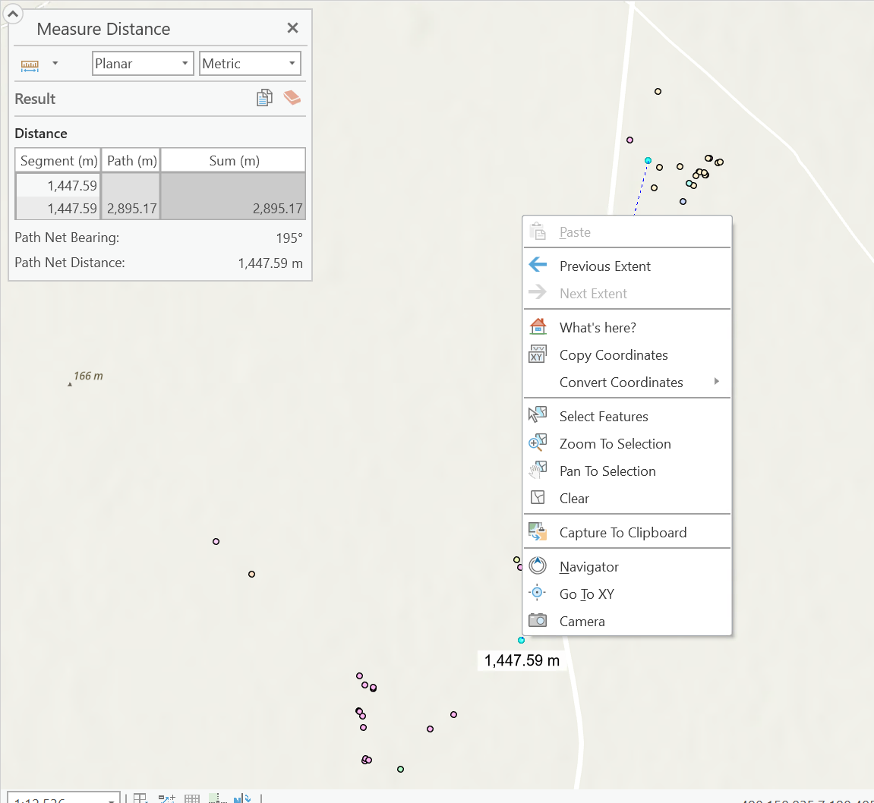

Web Mercator：

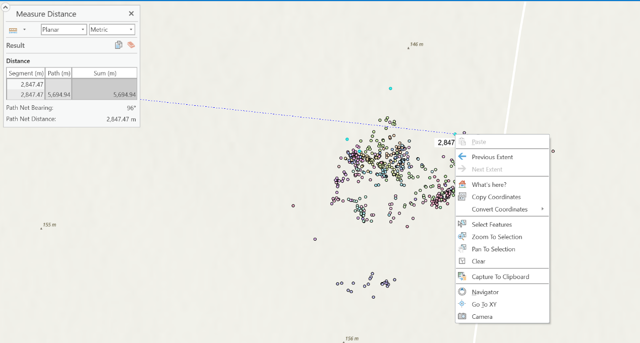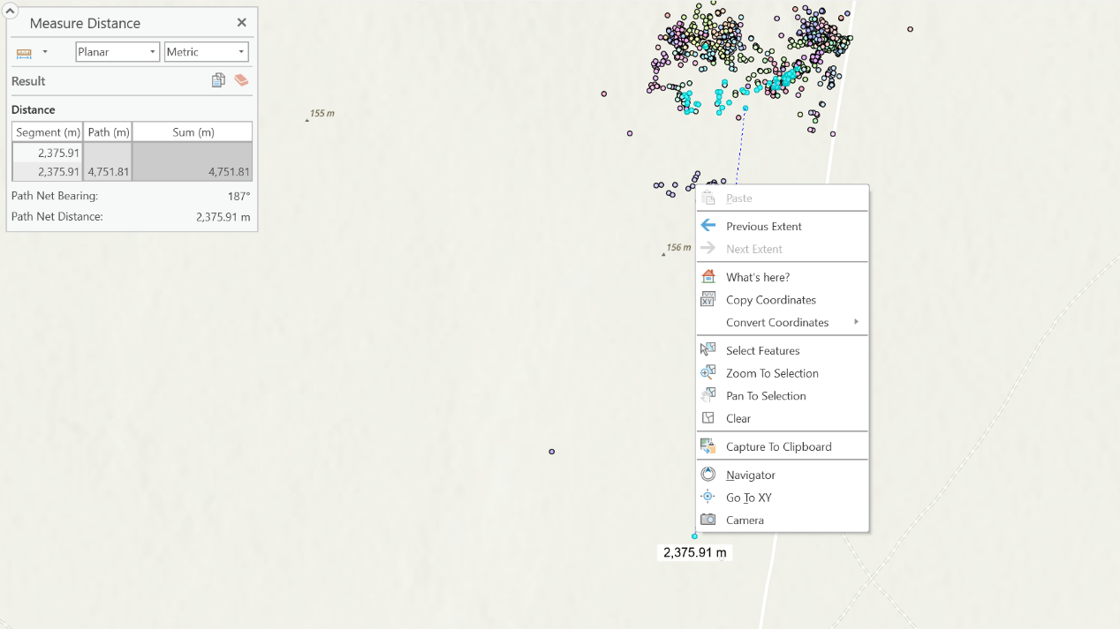

The sum of distances are very similar(there are errors because I estimated it annually when finding the center of one data point)

1. **Discussions**

Comparing the outcomes, I found the distance between two points didn’t vary when the PCS varied. It means physical distance won’t change because of the Projected Coordinate Systems. However, through calculation, the size of areas changes without any change of the unit. This means there are distortion of size when we use different PCS. Because the Earth's curved surface is not isometric to a plane, preservation of shapes inevitably requires a variable scale and, consequently, non-proportional presentation of areas. Similarly, an area-preserving projection cannot be conformal, resulting in shapes and bearings distorted in most places of the map. And this can cause distortion(difference) according to the location on the surface of the Earth and distance from the Equator.

**Bibliography**

Wikipedia. “Kenya,” September 9, 2022. <https://en.wikipedia.org/wiki/Kenya#Geography>.

Wikipedia. “Madagascar,” February 22, 2022. <https://en.wikipedia.org/wiki/Madagascar#Geography>.

Wikipedia Contributors. “Netherlands.” Wikipedia. Wikimedia Foundation, March 18, 2019. <https://en.wikipedia.org/wiki/Netherlands>.